API - Application Programming Interface

More information

* API is a software intermediary that lets two different applications talk to each other. Can also be thought of as a contract of service between two two applications.

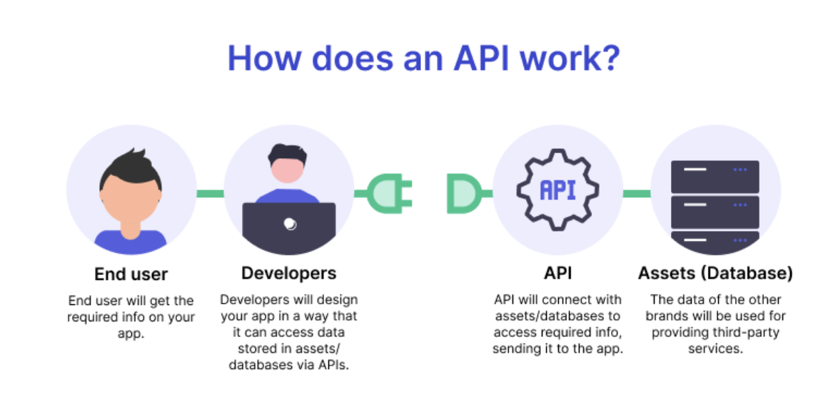

* Serves as the connector between the developer and the database.
* 4 ways APIs can work
  + SOAP
    - Simple object access protocol. Less flexible API that was used in the past.
  + RPC
    - Remote procedure calls. Client completes a function or procedure on server, and server sends the output back to client.
  + Websocket
    - Uses JSON to pass data. Supports 2-way communication. More efficient than Rest API.
  + Rest
    - Most popular and flexible ones used today, assuming we probably want to use one of these!
    - Client sends request to the server as data.
    - Representational state transfer
    - Defines GET, PUT, DELETE that clients can use to access data.
    - Lots of benefits to these.

Flask or Django python frameworks to mediate connection between MongoDB and react.

Sites for setting up flask with MongoDB:

<https://www.mongodb.com/compatibility/setting-up-flask-with-mongodb>

<https://medium.com/mlearning-ai/how-to-create-a-web-app-with-reactjs-mongodb-flask-and-fasttext-560fa2e1103c>

* Flask lets you interact with the database by doing HTTP requests.

Integrating Flask with MongoDB creates a strong and scalable application stack.

PyMongo is the official MongoDB driver for Python. Any Python application can use it.

Any Python application can consume the PyMongo driver by importing it and using the MongoClient instance.

Saw Kenadis notes on codehooks.io!

Found this website

<https://codehooks.io/blog/build-great-backend-apps-with-open-source-package-codehooks-mongodb>

* Javascript backend programming
* Has a free plan

How to get user input from mongodb to react!

<https://medium.com/create-a-clocking-in-system-on-react/handle-form-submissions-in-react-to-a-mongodb-backend-a90cac7c81e9>